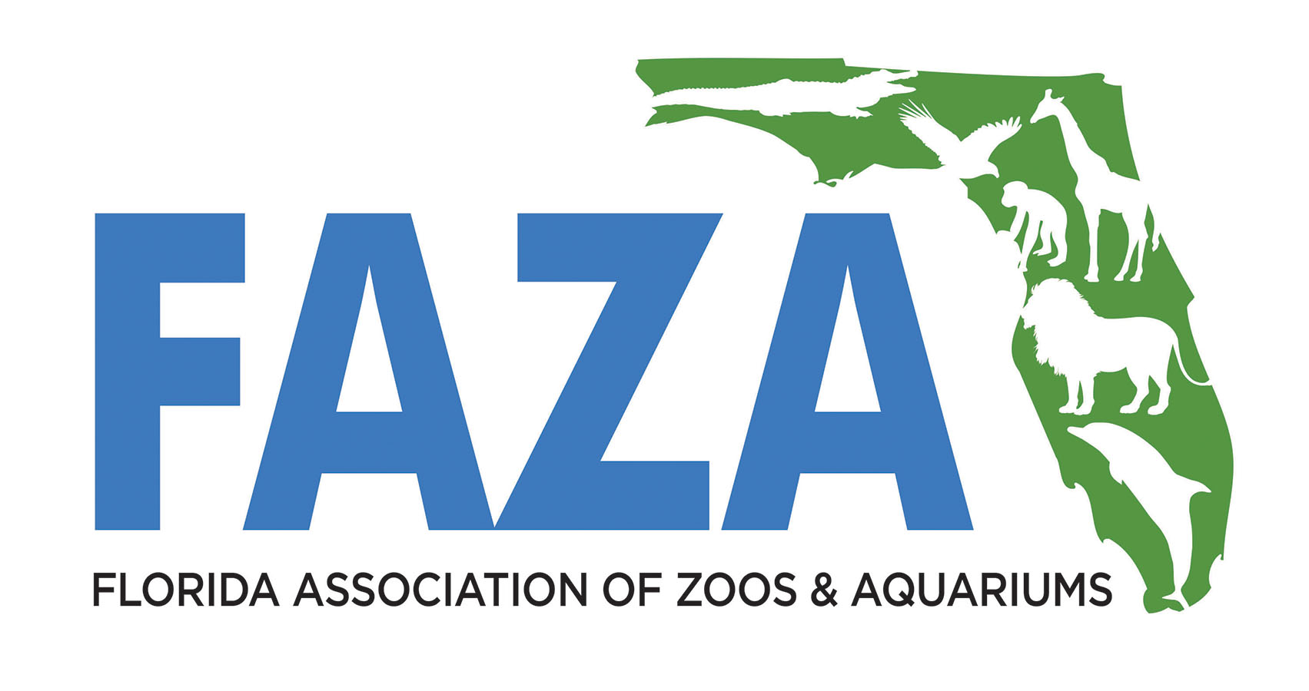
FAZA Staff
Shadow Program
Application

Submit initial application and follow up receipts and report to
FAZA Shadow Grant Coordinator Matt Seguin at mattseguin@mote.org

Deadlines
Application Due: April 15 - Awarded: June 1 | October 15 - Awarded: Dec 1
Experiences to be completed within 9 months. Report to be submitted 8 weeks after.
Approved grantees must be FAZA Associate Members prior to their Shadow experience. Join online at https://www.flaza.org/join-faza
____________________________________________________________________________________________
Name and contact information of program participant: (Who are you?)
Name:
Mailing Address:
City, ST, ZIP:
Email: Phone:
FAZA institution currently employed at: (Where do you work?)
Name:
Attach a copy of an email indicating approval from your home institution with this application.

FAZA institution participating in Shadow program: (Where do you want to go?)
Name:
Attach a copy of an email indicating approval from institution where you will shadow with this application.

Name and contact information of destination participant: (Who would you like to work with and learn more about?)
Name: Email:
Why did you choose this individual/facility for your shadow experience?

What specific techniques/knowledge do you hope to gain from this person or facility during this experience?
(Continued)
NOTE: If you need help contacting the someone at the facility you would like to shadow,
contact FAZA Shadow Grant Coordinator Matt Seguin at mattseguin@mote.org.
-----------------------------------------------------------------------------------------------------------------
Post-Experience Evaluation Report
A written 1-to-2-page report is due within 8 weeks following the experience including responses to the following for posting in the Members Only section of the FAZA website to further share lessons learned with colleagues.
Please include at least four pictures of you involved in the shadow experience approved for public viewing by the host institution.

Which facility and staff did you shadow?

What techniques/knowledge did you learn/gain?

How did you share this with your co-workers?
What changes do you hope to implement at your institution?

REIMBURSEMENT: FAZA will reimburse participants up to $250 for verified out of pocket expenses for travel, lodging, and food. Maximum reimbursement per diem for food is $30.
Please email a copy of your receipts to FAZA Shadow Grant Coordinator Matt Seguin at mattseguin@mote.org.

-------------------------------------------------------------------------------------------------

