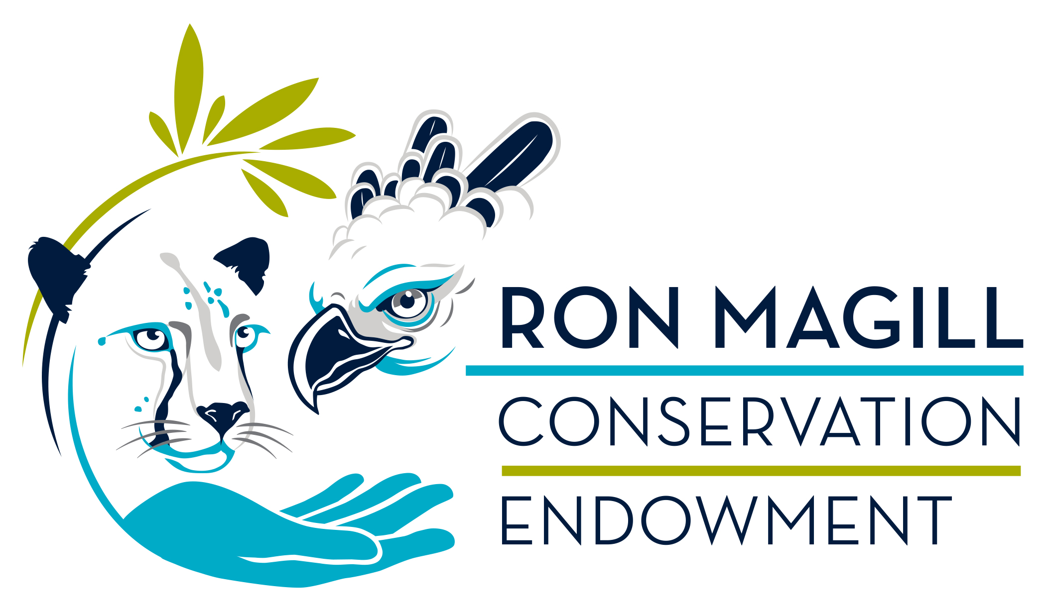
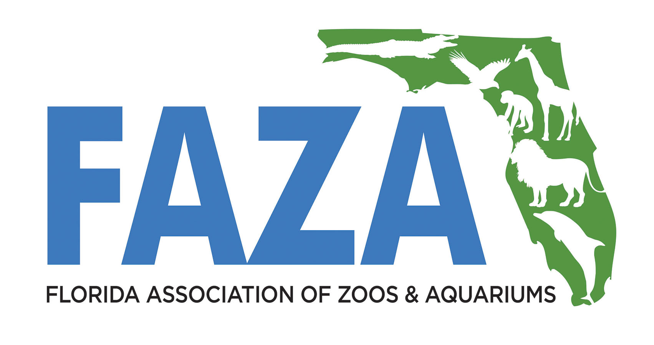

FAZA’s Ron Magill Conservation
Endowment Grant Application

In order to assist staff of AZA-accredited and certified facilities to participate in efforts to benefit wild plants and animals in Central and South America and the Caribbean, the Ron Magill Conservation Endowment Grant provides matching dollars to cover travel costs up to $2,500. This grant is intended to assist non-management or early career recipients. Evaluation is weighted to provide significant preference for these candidates. $5,000 is available each year.

Recipients can use their skills in projects that benefit in situ populations although actual work may be done ex situ. Examples include: using keeper skills to increase success in headstarting programs or rehab facilities which return animals to the wild; research support or capacity building/training for a field program; efforts to develop communication plans to educate communities impacting flora and fauna; financial or development capacity building to improve effectiveness of conservation program; or other efforts that meet the AZA-approved definition of field conservation.

Expenses that can be matched include airfare, visa, in-country transportation, housing, and up to a $30 per diem. Example: a 10-day trip with a $1,000 airfare, $300 housing, $200 in-country travel costs, $160 visa, plus up to a $300 per diem totaling $1,960 would be reimbursable at up to $980. Incidental expenses including personal travel accessories, passport, and US travel costs are NOT reimbursable. While vaccinations are NOT reimbursable, required vaccines can be used for matching dollars. All reimbursable expenses and matching dollars require receipts. Salary cost covered by a home institution is not considered for reimbursement or matching purposes.

Reporting: Recipients must provide a written report within 8 weeks after returning from the project including lessons learned or ways in which the skills the recipient has were shared to benefit the project. Recipients should also submit three high resolution photos showing their participation in the project.

Deadlines: June 1 and November 1 each year. | Award notifications 6 weeks after. All decisions are final.

Submit this application and electronic copy of receipts to the
FAZA Conservation Committee Chair at JPalmer@brevardzoo.org.
Name and contact information of applicant:
Name:
Mailing Address:
City, ST, ZIP:
Email: Phone:

AZA institution currently employed at:

Total Estimated Expenses (receipts required for final total):
NOTE: Grant recipients can be reimbursed for early expenses like airfare with a second reimbursement paid upon return for remaining receipts.

In 300 to 500 words, describe what specific skills the recipient has that will be used and how the recipient’s efforts will benefit wild populations of plants or animals. Include relevant websites or helpful documents as well as likely travel dates and length of time assisting in project:

----------------------------------------------------------------------------------------------
Conservation Project Confirming Recipient’s Potential Participation:
Name of Contact:
Email:
----------------------------------------------------------------------------------------------
Recipient’s Recommending Supervisor or Other Management:
Name:
Email:
----------------------------------------------------------------------------------------------
INFORMATION BELOW TO BE FILLED OUT BY FAZA

Application Approved: YES / NO

Reimbursed Amount Payment One: _________________________________

Date Compensation Check Mailed: __________________________________

Reimbursed Amount Payment Two: _________________________________

Date Compensation Check Mailed: ___________________________________

