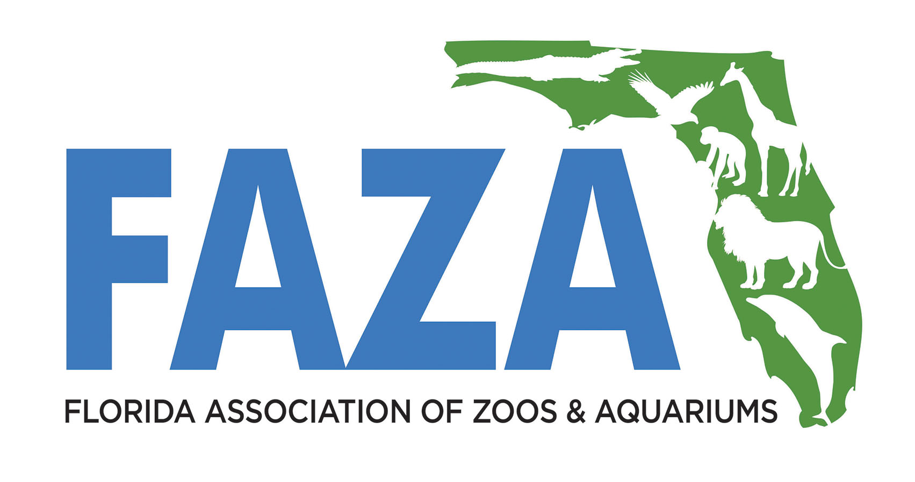
FAZA Staff
Shadow Program
2020 Application

Today's Date:

Submit application, receipts, and report to
FAZA Treasurer Liz Harmon at liz@napleszoo.org.

Deadlines: Application: March 2, 2020 | Awarded: April 1, 2020 |
Complete by Dec 31, 2020
NOTE: Eight grants up to $250 each will be awarded in 2020. Individuals must be FAZA members prior to their Shadow experience.
Name and contact information of program participant: (Who are you?)
Post-Experience Evaluation Report
A written 1 to 2 page report sharing the techniques/knowledge gained from the experience is due within 8 weeks following the experience including any ideas implemented at your home institution.

Name:
Email: Phone:

FAZA institution currently employed at: (Where do you work?)
Name:

FAZA institution participating in Shadow program: (Where do you want to go?)
Name:

Name and contact information of destination participant: (Who would you like to work with and learn more about?)
Name:
Email: Phone:
What do you hope to gain? (What techniques/knowledge would you like to learn?)

REIMBURSEMENT: FAZA will reimburse participants up to $250 for verified out of pocket expenses for travel (gas receipt, bus ticket, etc.), lodging, and food. Maximum reimbursement per diem for food is $30. Please email a copy of your receipts to FAZA Treasurer Liz Harmon at liz@napleszoo.org.

-------------------------------------------------------------------------------------------------
Approval of Your Home Institution:
Name:
Electronic Signature or Approval:
Date:

Approval of Shadow Location Institution:
Name:
Electronic Signature or Approval:
You Can Also Attach a Copy of an Email Indicating Approval.
NOTE: If you need help contacting the someone at the facility you would like to shadow, please contact Liz Harmon at liz@napleszoo.org.
Approval Date:

Please return this form to liz@napleszoo.org
Questions? Call 239.262.5409 ext 141
--------------------------------------------------------------------------------------------------
INFORMATION BELOW TO BE FILLED OUT BY FAZA
Approval of FAZA Treasurer
Application Approved: Application Not Approved:

Date:
Date Receipts received: Date Expense Check Mailed:

Report Received/Distributed to FAZA & Shadow Closed:

