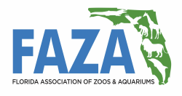
Associate Level
Membership Application

Existing Member New Member
First Name:
Last Name:
Facility (if applicable):
Current Position:
Areas of Focus:
If Not Employed by FAZA Member Institution, Person Nominating for Membership:
Preferred Mailing Address:
City:
State: Zip Code:
Phone Number: ( ) - ext
Your Official Institution E-mail:
If You Do Not Have Institution E-Mail, Please Provide E-mail of Person at Institution Who Can Confirm Employment:
Signature: _____________________________________________________________________
E-mail or mail this to FAZA Membership Committee Chair below:
Rob Yordi Email: robert.yordi@seaworld.com
ATTN: FAZA Membership Phone: 407-226-6060
SeaWorld Parks & Entertainment
9205 Southpark Center Loop
Orlando, FL 32819

